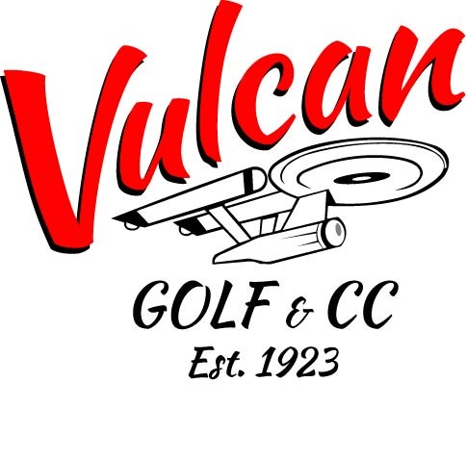

COVID-19 RULES AND REGULATIONS April 9,2021
As per the recent announcement by The Alberta Government we are moving back to stage 1 of the recent lockdown. Please make yourself familiar with our rules and regulations for the Vulcan Golf and Country Club.
- When checking into the clubhouse please wear your mask.
- When moving around the clubhouse please wear your mask.
- Our restaurant is open for take out and patio dinning.
- Washrooms are open on the course and clubhouse
- Please do not touch the flag pole.
- Rakes are not on course. (feel free to improve your lie)
- There are no working ball washers on course
- Please obey all signage
- Golf carts are sanitized between rounds.
- Please drop off carts on North side of Parking Lot

The clubhouse is sanitized and cleaned at least 3 times a day.
We would like members of the same family to share a golf cart. If you have arrived in the same vehicle it is permitted to ride together. If you do not feel comfortable sharing a golf cart you are welcome to ride alone.

If you have any concerns or questions, please contact us at 403-485-2553 or send an email to golfvulcan1@gmail.com

